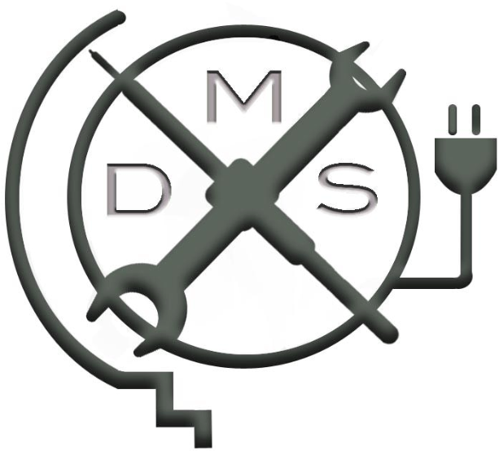
Davis Maker
Space

Repair Café

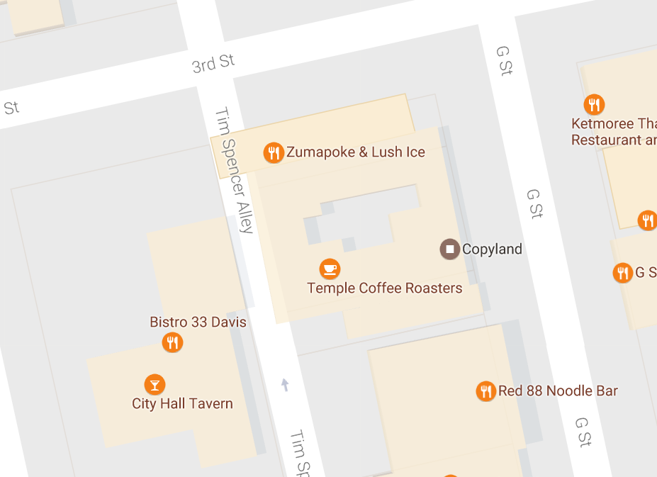
Time:
Sunday Feb 12th 11 am to 8 pm

Located:
Tim Spencer Alley

LOOKING FOR people with a knack for fixing things. Come join the fun!
SERVING people that have things that need fixing. Bring your stuff!

Contact: Rob at rob@omsoft.com for more information

